Zesty Baked Tilapia
Dinner in less than 30 minutes!

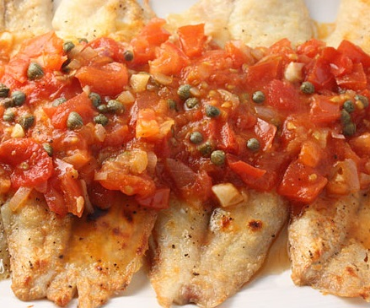
Ingredients
16 oz frozen tilapia fillets, thawed and patted dry
2 teaspoons ground cumin
1 teaspoon ground black pepper
1/2 can Ro-Tel tomatoes, drained
1 Tbls capers

Directions
Preheat oven to 400 degrees. Lay tilapia fillets
in 9 x 9-inch baking dish. Sprinkle cumin and
black pepper over fish. Add tomatoes; sprinkle
cheese on top. Bake 20 minutes or until fish
flakes easily with fork.

Add a green salad and youre set!

Makes 2 servings

Nutrition Facts:
Calories 220
Total Fat 1g
Effective Carbohydrates 3.5g
Protein 30g

