Chocolate Raspberry Brownies
Delectable dark chocolate brownies with a surprise layer of raspberry jam.

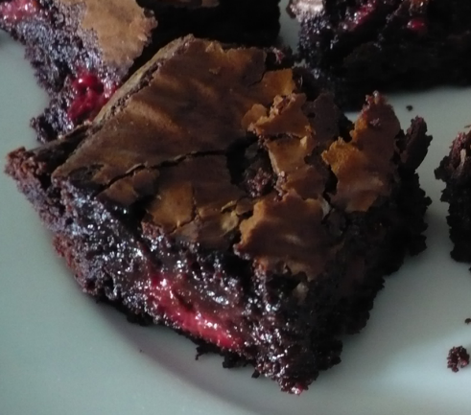
Ingredients
4 oz unsweetened baking chocolate
¾ cup butter
¼ cup low fat cream cheese
4 large eggs
½ cup Splenda for baking
½ tsp salt
1 cup flour
1 ½ cup chopped walnuts
4 oz semi-sweet chocolate chips
1 cup raspberry jam (no sugar added)

Directions
- Preheat the oven to 350 degrees. Spray a 9 x 13 pan with nonstick cooking spray.
- Melt butter and unsweetened chocolate in a microwave safe dish for 1 minute on 50 percent power. Stir. Continue cooking in microwave in 30 second increments until chocolate is melted. Whisk in cream cheese
- Beat eggs, sugar, and Splenda together in a large mixing bowl.
- Stir in chocolate mixture, vanilla, and salt. Add flour and mix well. Stir in walnuts and chocolate morsels.
- Pour half the batter into a prepared pan.
- Heat raspberry jelly in microwave until smooth. Pour over brownie batter in pan.
- Freeze for 20 minutes or until jelly is set.
- Pour remaining brownie batter on top of jelly. Bake for 45 minutes or until a toothpick inserted in the center of the brownies comes out clean.

Makes 32 servings

Nutrition Facts: (per serving)
Calories 176.3
Total Fat 11.2g
Total Carbohydrates 15.2g
Dietary Fiber .9g
Protein 2.9g

From dlife.com

