Pears with Creamy Cinnamon Dip
Fresh pears served with a cream cheese/cinnamon dip.

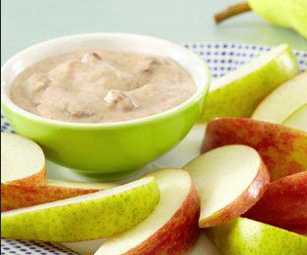
Ingredients
4 oz Cream Cheese, light, classic
2 tbsp sugar
3/4 tsp ground cinnamon
1/4 cup fat free milk
1/2 tsp vanilla extract
2 each medium pears

Directions
- Place the cream cheese, sugar, and cinnamon in a bowl and beat on a low speed until blended.
- Add the milk and vanilla and beat until smooth. Serve with pears.

Makes 3 servings

Nutrition Facts:
Calories 173.3
Total Fat 7g
Total Carbohydrates 28.1g
Dietary Fiber 4.2g
Protein 5.2g
From dlife.com

